**Quality Definition, Planning and Review:** GotoGro-MRM

**Plan for Quality Testing**

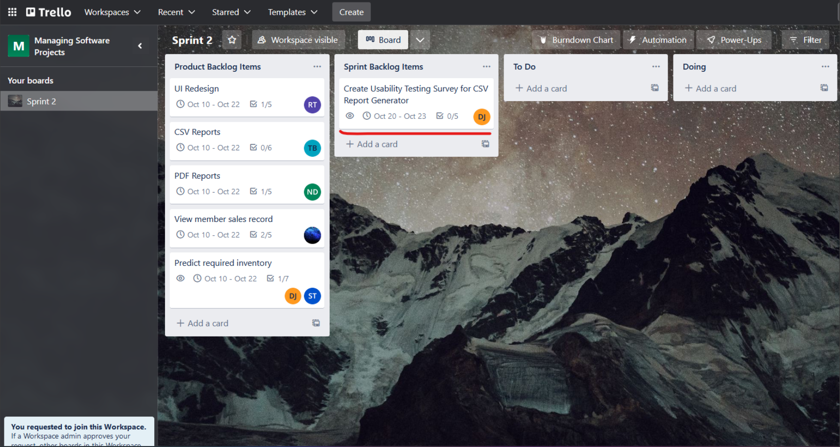Following the descriptions in 71D, a suitable survey must be created to demonstrate the software actually meeting the requirements. ***Figure 1*** shows the testing item listed on the Trello board:

***Figure 1:*** *Testing backlog item on Trello board.*

As part of this item, the specific questions have been listed as well as generic descriptions to help complete the task (following the completion of the product in question). Subsequently the dates assigned to the testing item are the days directly after Sprint 2 as this will be after the product is working. **Figure 2** displays the recommended survey questions:

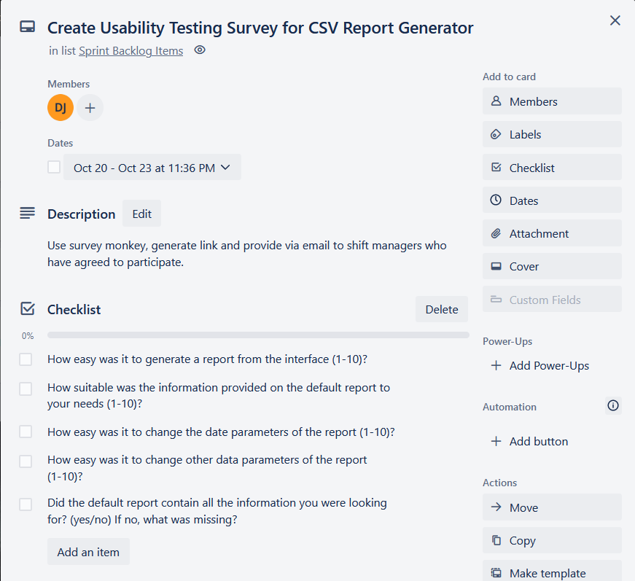

***Figure 2:*** *The creation plan for the quality survey as shown on the Trello card.*

The questions at hand are acceptable to generate a usability baseline for this specific product as they address the 4 primary usability areas: being product suitability, efficiency, intuitiveness and accuracy.

In order to keep the survey valid, its integrity can be maintained in two ways: First, by ensuring the usability of the survey itself is ideal. And second, by validating the identities of the users filling out the survey (ensuring they are actual shift managers and therefore offering reasonable data that should be included in the quality metrics).

To maximise usability, the free tool Survey Monkey will be used to create the survey. This is a common tool many people will be familiar with and is also very intuitive which will minimise the chance that the survey feedback data is inaccurate due to user input errors or misclicks.

Ensuring the quality of the data entry is more difficult as we will obviously not have a wide range of “shift managers” to test from. For this project specifically, the greatest usability opinion will come from our tutor, with supporting opinions potentially from other teams. Another simple step we could take to ensure data validity is to be present while the member in question is filling out the survey as they are more likely to do it properly in that case.

**Figure 3** shows a snippet of the survey taken from the Survey Monkey backend.

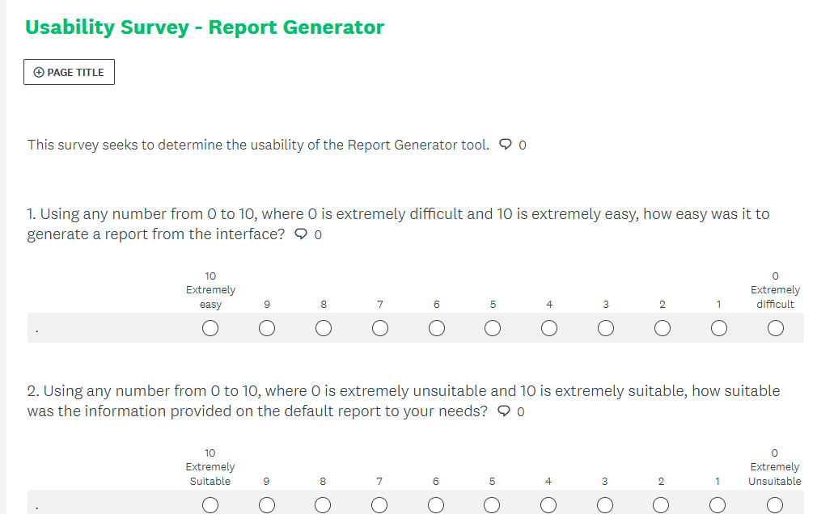***Figure 3:*** *First two questions of survey.*